Experiment 10: write an Arduino program to control operation of Servo Motor with Arduino Uno.

**INTERFACING SERVO MOTOR**

AIM: To write an Arduino program to control operation of Servo Motor with Arduino Uno.

**APPARATUS REQUIRED:**

1. PC

2. Arduino IDE

3. Bread Board-1No

4. Servo Motor-1No

5. Wires**CIRCUIT DIAGRAM:**

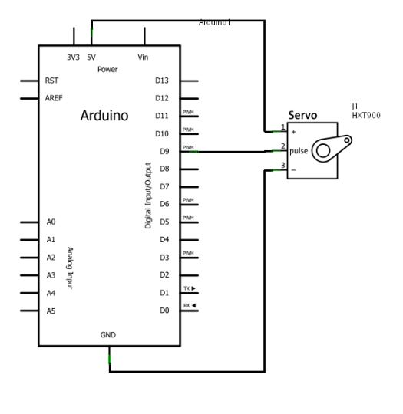

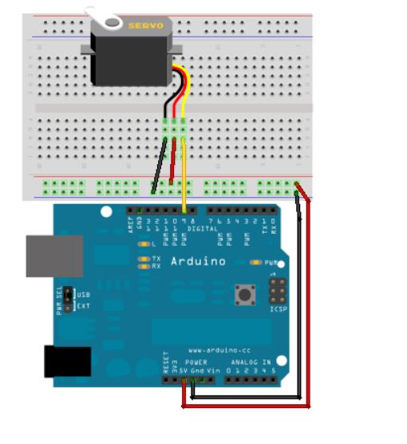

**PROCEDURE:**

1. Connect the circuit as per the circuit diagram.

2. Connect Arduino to your PC.

3. Open the Arduino IDE in computer and write the program.

4. Compile the program for any errors and upload it to the Arduino.

5. Observe the output LED ON when pressing Push Button.

**PROGRAM:**

#include <Servo.h>

Servo myservo; // create servo object to control a servo

// a maximum of eight servo objects can be created

int pos = 0; // variable to store the servo position

void setup()

{

myservo.attach(9); // attaches the servo on pin 9 to the servo object

}

void loop()

{

for(pos = 0; pos < 180; pos += 1) // goes from 0 degrees to 180 degrees

{ // in steps of 1 degree

myservo.write(pos); // tell servo to go to position in variable 'pos'

delay(15); // waits 15ms for the servo to reach the position

}

for(pos = 180; pos>=1; pos-=1) // goes from 180 degrees to 0 degrees

{

myservo.write(pos); // tell servo to go to position in variable 'pos'

delay(15); // waits 15ms for the servo to reach the position

}

}

RESULT: Thus the Servo Motor operation is controlled by using Arduino Uno.